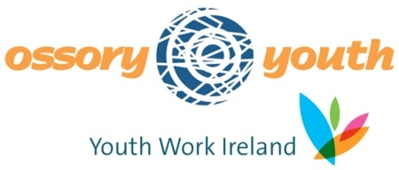
Ossory Youth’s Craft Workshops

Registration Form
Youth Club Name: _______________________________________
Contact Person: _______________________________________
Contact Number: _______________________________________
Craft you wish to learn: _______________________________________
What Ossory Youth can bring:
- Ossory Youth will work with volunteers to train them up to the best of our ability.
- Ossory Youth will work with volunteer leaders to ensure they understand the craft being thought.
- Ossory Youth will source craft packs needed for the club, if the club decides to invest in one.
- Learn step-by-step how to create and teach your chosen craft, discover what tools and materials are required and the techniques needed.
Terms and Conditions:
- Our Youth Club will have a venue suitable to hosting the Craft Workshop.
- Our Youth Club will source the volunteers interested in learning the craft and will take responsibility for their attendance.
- The cost of the craft workshop is €25 per person, paid to Ossory Youth for equipment and materials. This is a standard cost. The Youth Club is willing to cover this cost in the craft workshop

I agree to these terms and conditions. (Signature)____________________________________

I wish to book Ossory Youth’s “Craft Workshops” for delivery on the ___________________

Enclosed please find the standard cost of €__________ (€25 pp, Maximum 6 persons)

If you have any queries, please contact Martina Maher on 056 7761200

